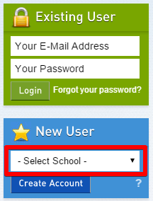
- EXISTING USER?
- Visit www.myBlueprint.ca
- Enter your email address and myBlueprint password in the Existing User Box
- Click Login
Forgot your password? Click on “Forgot your password?”

- NEW USER?
- Visit www.myBlueprint.ca or the District Landing Page
- In the New User box, enter your child’s school Activation Key or select your child’s high school from the list and click Create Account
- Click Not a Student? Teachers, Counsellors, and Parents sign up here
- Select Parent/Guardian/Advisor
- Fill out the sign up form
Don’t have your Activation Key/District Landing Page?
Talk to your child’s counsellor or email help@myBlueprint.ca
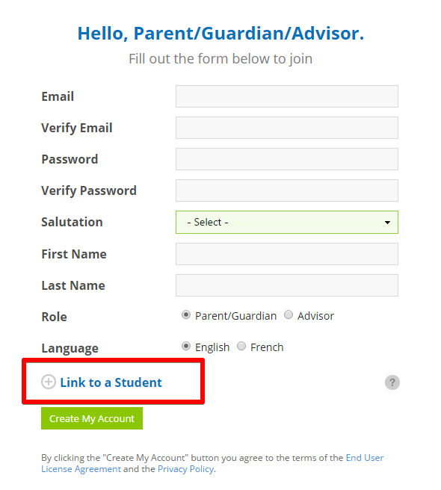

- LINK WITH YOUR CHILD (Optional)
- You can link with your child to view their myBlueprint account
- From the sign up page, click on Link to Student
- Enter your child’s email address associated to their myBlueprint account
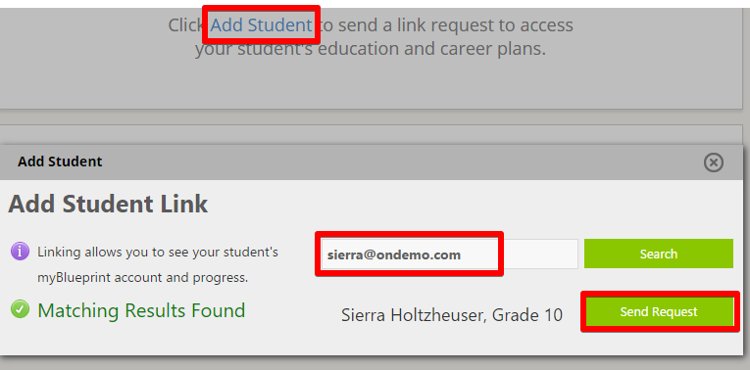
Don’t know your child’s email address?
You can link to them later!
- Log in to your account
- Click Add Student
- Enter their email address and click Search
- Once Matches are found, click Send Request

- EXPLORE STUDENT FEATURES
From your Dashboard, click Go to Student View to access a demo student account to explore the features of myBlueprint.

- Post-Secondary Planner – compare detailed information on apprenticeships, college programs, university programs and workplace sectors across Canada
- Career Spectrum – complete 6 unique assessments for self-exploration and discovery (including Learning Styles, Myers-Briggs Personality, Holland Interests, Knowledge, Motivations, and Compatibility) and be matched with suited occupations
- Goal Setting – add interactive SMART goals and action plans
- High School Planner – visually plan courses, track progress toward graduation, and instantly identify post-secondary eligibility for opportunities in every pathway
- Occupation Planner – compare comprehensive information on occupations
- Resume & Cover Letter – record experiences, build a resume, write a cover letter
- Financial Planner – build a budget to track income and expenses
- Job Finder – find real-world job postings that relate to occupations of interest
- My Portfolio – create a personal or career portfolio and share it with parents, teachers, or future employers

